**ACTIVITY: MAINTENANCE OF PUMPS**

**Objective: -** Safe and quality maintenance of pump for optimum out put

**Scope : -** Blast Furnace Accessories

**Ref. : -** Pumps maintenance manual

**Responsibility : -** Engineer In charge & Maintenance Fitter on job

**PPE s to be used:**

• Helmet, Safety shoes, Hand gloves, Dust mask, and complete sealed goggle

**Aspect** - **impact**

|  |  |
| --- | --- |
| Oil Spillage | Land contamination |
| Scrap generation | Resource Depletion |

|  |  |
| --- | --- |
| Draining of water | Resource Depletion |

|  |  |
| --- | --- |
| Oil traced waste generation  **Hazards identified** | Land contamination & Resource Depletion |
| **Physical Hazard -** | Pressure, temperature-hot water, dust inhalation, , congestion, splash of hot water while working near pump bursting of rubber expansion bellow. |

**Mechanical hazard –**

* Trapping in between coupling, impeller, guard, dismantled pump and motor, etc.
* Entanglement in between moving parts, guard, coupling.
* Fall of spare parts, rod, slinged items, tools, hammer, etc.
* Fall of person from platform & height.
* Impact of moving/slinged items.
* Injury from slip of pump component while assembly / dismantling.
* Impingement of fingers, hand while fitting assembly of pump, bearing fixing, impeller fixing, flange joint tightening.
* Bursting of rubber expansion bellow due to high pressure.

**Electrical Hazard** – Electric Shock due to welding machine, cable and damaged wire.

* **Splashing of hot water on side pump, motor , .electrical panel**

**Chemical hazard -** Co gas poisoning & Fire

**Biological Hazard** - Bee sting

**Human Behavior aspect of operators**:

Operator nature, alcoholism, casual approach, horse play, use of mobile at workplace, back pain & non usage of PPE?s

**Work No 1**: Changing of pump assembly.

**Work No 2**: Changing of gland rope.

**Work No.3**: Overhauling of pump.

**Work No.4**: Changing of pump casing.

**Work No.5**: Changing of pump base frame.

**Work no 6**: Installation of rubber expansion bellow.

1. Most of the pump problems can be pre detected with the help of current analysis.
2. Low current indicates pump running without any load hence blockage of suction/ delivery/ impeller de-coupled/ shaft failure /reverse direction, etc.
3. High current indicates pump running with additional load due to jamming up of bearings/ impeller/ gland etc

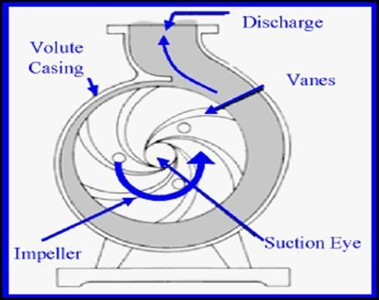

# Rotating and stationary components

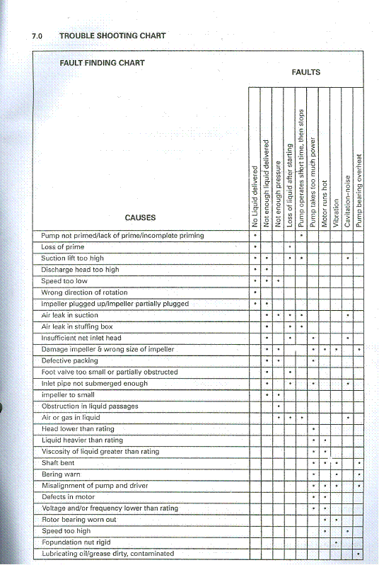

# Work No 1: Changing of pump assembly For End suction pumps

1. Take work permit from Production dept
2. Take electrical shutdown of the pump from electrical engineer using LOTO.
3. Close suction and discharge valves and depressurize the casing by opening vent valve / pug in casing
4. Remove coupling guard and de- couple to isolate pump from the motor.
5. Drain the oil in an oil-can with care. Remove oil cup with care to avoid breakage in handling. Applicable to pumps with lubricating oils
6. Open the casing bolts with correct size spanner. Keep two bolts loose.
7. Sling the pump assembly with chain pulley bock on monorail trolley / hydra. Adequate care must be taken while taking help of Hydra for erection as minute adjustment with hydra operator may be difficult.
8. Remove pump assembly from casing by tightening jack bolts. Due care to be taken to avoid fall of pump assembly on legs or entanglement.
9. If impeller is to be replaced, remove the impeller nut and fix new impeller. The Impeller should be tight on shaft and lock nut should be fixed with washer / gasket.
10. Pump assembly has to be shifted as per material handling procedure (WI/MAINT/12)
11. Replace gasket, O-rings and damaged studs if any.
12. Inspect the casing wear ring for wear and replace it with new one if required.
13. Sling the pump assembly and insert inside casing. Fix bolts and uniformly tighten the same.
14. Fix L support below pump assembly.
15. Align with dial gauge within 10 divisions of dial gauge for axial and radial directions.
16. Couple the pump with motor and fix guard.
17. Fill oil (Enklo 68-turbinol) after fixing plug and oil gauge.
18. For grease lubricated pumps, apply grease (Balmerol licom-3) in bearings by hand rotation of rotating assembly
19. Do handle oil with utmost care to avoid the spillage. Use the lubricant recommended as per maintenance manual and as per procedure WI/MAINT/92
20. Open suction and discharge valve of pump. Check for leakage.
21. Fix back the motor cover.
22. Before starting pump, re-check oil level / grease in bearings
23. Clear electrical shutdown and take trial of pump.
24. Measure vibration, current, pressure, gland leakage, casing leakage.
25. If found within acceptable limits, Give clearance to production department.
26. Carry out housekeeping activity as per work procedure VL/IMS/PID1/MECH /WI/91.

# For Split Casing pumps

1. Take electrical shutdown of the pump from electrical engineer.
2. Close suction and discharge valves and depressurize the casing by opening vent valve & pug in casing
3. Drain the pump by removing drain plug and opening air vent valve.
4. Remove coupling guard and de- couple to isolate pump from the motor.
5. Remove all top bottom flange, nuts and locating pin. Remove flush piping.
6. Insert a screw driver or peg bar into the slot between the two halves and separate two halves, lifting off the upper half casing.
7. Sling the pump upper half casing with chain pulley bock on monorail trolley / hydra.
8. Tap the inserts with a soft hammer to break the seal between the insert and lower half casing and lift the rotating unit out of the lower half casing. Due care to be taken to avoid fall of pump assembly on legs or entanglement.
9. Pump assembly has to be shifted as per material handling procedure to site
10. Replace gasket, O-rings and damaged studs
11. Inspect the casing wear ring for wear and replace it with new one if required.
12. Sling the new or repaired pump rotating assembly and insert inside casing.
13. Install casing gasket with a light coat of grease on both gasket surface. Carefully align the inner edge of the gasket with the insert O ring
14. Put the casing upper half into place and engage casing joint nuts loosely.

**Note:** When installing casing half upper make sure that the O ring are not cut or punched.

1. Insert locating pin and tighten the joint nuts.
2. Install stuffing box flushing piping.
3. Fix the bearing housing with the casing.
4. Align with dial gauge within 10 divisions of dial gauge for axial and radial directions.
5. Couple the pump with motor and fix guard.
6. Fill oil after fixing plug and oil gauge.
7. For grease lubricated pumps, apply grease in bearings by hand rotation of rotating assembly
8. Do handle oil with utmost care to avoid the spillage. Use the lubricant recommended as per maintenance manual and as per procedure VL/IMS/PID1/MECH /92.
9. Open suction valve and discharge valve of pump. Check for leakage.
10. Fix back the motor cover.
11. Before starting pump, re-check oil level / grease in bearings
12. Clear electrical shutdown and take trial of the pump.
13. Measure vibration, current, pressure, gland leakage, casing leakage.
14. If found within acceptable limits, Give clearance to production department.
15. Carry out housekeeping activity as per work procedure

VL/IMS/PID1/MECH/WI/91.

# Work No 2: Changing of gland rope

1. Take work permit from concerned production dept. Take electrical shutdown of the pump from electrical engineer. For minor tightening of gland during running, electrical shutdown is not required.
2. Remove the gland follower with proper spanner and check stud and nut for thread damage/corrosion and replace if required.
3. Remove the existing gland rope from stuffing box with the help of screw driver/sharp pointed rod and check shaft protection sleeve for wear out. If found damaged then change the pump assembly as per pump changing procedure.
4. Pack up/put in new gland rope of appropriate size and length as required.
5. Refit pressure ring and gland follower in position; press the gland rope by tightening stud nut, & rotate pump shaft for freeness.
6. Clear electrical shutdown and take pump trial. If leakage still persists, then slightly tighten the gland and give clearance to production department.

**Note:** Excessive gland pressure will cause damage by cutting off lubrication to the packing and packing will burn and damage the sleeve

# Work No.3: Overhauling of pump

1. Drain the oil completely of the pump to be overhauled in tray and pour it in waste oil reservoir.
2. Start disassembling the pump in an overhauling tray.
3. While overhauling of the pump, check each frictional part of the pump for wear out, bearing conditions, oil seal damage, shaft condition, mechanical seal condition, etc. as per problem faced in the assembly. Replace worn-out/damaged part if any.
4. Re-assemble with new oil seal ring, gasket packing, gland rope, etc.
5. Check impeller, impeller nut, and shaft threading before fixing impeller, and tighten it thoroughly.
6. Check coupling for looseness, wear out/damage. Refit coupling with proper key and grub screw.
7. Check leakage by filling oil in bearing block. Ensure drain port is plugged.
8. Rotate shaft for freeness.
9. Tag the overhauled assembly with job description, date of overhauling and keep in allotted area as ready to use spare assemly.

# Work No.4: Changing of pump casing

1. Take work permit from Production dept
2. Take electrical shutdown of the pump from electrical engineer.
3. Remove pump assembly as per work procedure of pump assembly changing.
4. Remove the casing by removing the bolts, with the help of chain block/Hydra if required. Ensure proper sling and D-shackle is used.
5. Replace new/Reconditioned casing in position. Ensure minimum 2mm shims is inserted below casing base for alignment purpose and tightene thoroughly.
6. Follow pump assembly changing procedure for fixing back the pump assembly.

# Work No.5: Changing of pump base frame

1. Take work permit from production dept.
2. Ask electrical to disconnect the motor.
3. Dismantle the pump assembly and casing as per procedure 1 and 4.
4. Remove motor from base frame with the help of hydra / chain pulley block as per site conditions; and keep away from working area.
5. Remove foundation bolts & nuts with proper spanner and check for any damage. Replace with new base frame. Ensure frame is water levelled with the machined wedges, and ensure that bolts have been tightened thoroughly.
6. Fix back the casing and pump as per procedure 1 and 2.
7. Fix back the motor with hydra / chain pulley block as per site conditions. Align as per procedure 1.
8. Ask electrical to connect the motor and check direction of motor as required.
9. Take de-couple trial of motor and note down the vibration readings.
10. Follow procedure of work no: 1 for trial of pumps.
11. If all parameters are ok, then give clearance to production department.
12. Carry out housekeeping activity as per work procedure VL/IMS/PID1/MECH/WI/91.

**Work no 6**: Installation of rubber expansion bellow

1. Inform production and take electrical shutdown of pump for which rubber expansion bellow is to be fitted.
2. Take electrical and mechanical isolation of suction and discharge valve, ensure zero energy.
3. Remove distance piece above pump discharge casing which is below discharge gate valve.
4. Fit the expansion rubber bellow by bolting.
5. Ensure to cover the bellow with plate cover as a precaution to avoid water splashing out in case of bellow failure.
6. In case of bellow failure pump to be stopped and both suction and discharge valve to be closed.
7. Clear electrical and mechanical isolation and ask production to take trials.
8. Below is specified to work at 10 kg/cm2 pressure, whereas our pump working pressure is 4-5 kg/cm2.

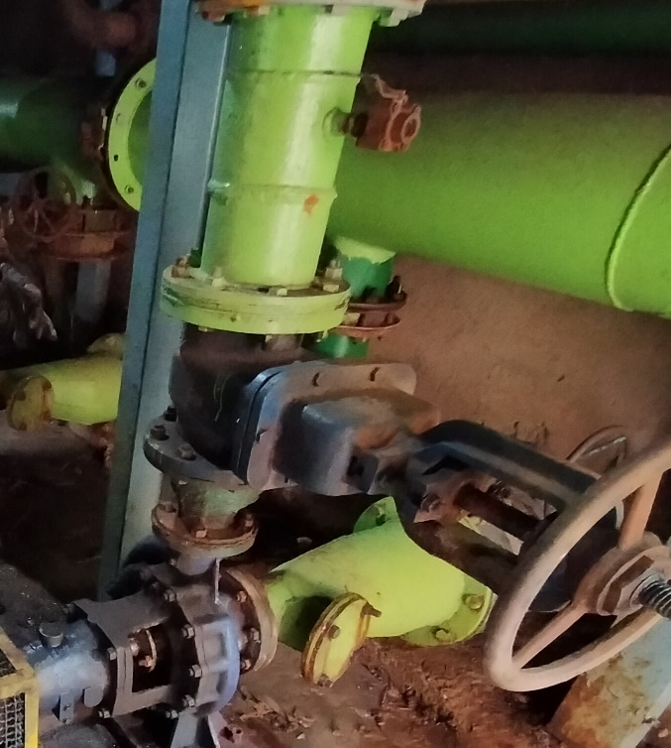

EXPANSION BELLOW WILL BE FITTED IN THIS PLACE

# ROUTINE MAINTENANCE CHART

|  |  |
| --- | --- |
| EVERY WEEK | VISUALLY CHECK FOR LEAKS, CHECK FOR  VIBRATION, ADJUST GLAND AS NECESSARY TO  MAINTAIN SLIGHT LEAKAGE, HAND TEST BEARING  HOUSING FOR ANY SIGN OF TEMPERATURE, VOLTAGE & CURRENT |
| EVERY MONTH | CHECK BEARING TEMPERTURE WITH A THERMOMETER/TEMPERATURE GUN |
| EVERY 3 MONTH | CHECK GREASE LUBRICATED BEARINGS |
| EVERY 6 MONTH | CHECK THE PACKING AND REPLACE IF NECESSARY,  CHECK SHAFT SLEEVE FOR SCORING, CHECK  ALIGNMENT OF PUMP AND MOTOR, CHECK HOLDING  DOWN BOLTS FOR TIGHNESS, CHECK COUPLING BUSH/RUBBER STAR |
| EVERY YEAR | CHECK ROTATING ELEMENT FOR WEAR, CHECK WEAR RING CLEARANCES, CLEAN AND REGREASE  BEARINGS, MEASURE TOTAL DYNAMIC SUCTION AND DISCHARGE, HEAD AS A TEST OF PIPE CONNECTION |

# PROBLEM ANALYSIS

|  |  |
| --- | --- |
| **CAUSES** | **REMEDIES** |
| Pump not primed-lack of priming-incomplete priming | Fill pump and suction pipe completely with liquid |
| Loss of prime | Check for leak in suction pipe joints and fittings. Vent casing to remove accumulated air. Check foot valve for damages |
| Suction lift too high | If no obstruction at inlet, check for pipe friction losses. Static lift may be too great, measure with vacuum gauge while pump operates. If static lift is too high, liquid to be pumped must be raised or pump lowered. |
| Discharge head too high | Check pipe friction losses. Larger piping may correct condition. Check that valves are fully open. Check total head at site. |
| Speed too low | Check whether motor is directly across the line and receiving full voltage. Frequency may be too low. Motor may have an open phase |
| Wrong direction of rotation | Check motor rotation with directional arrow on the pump casing |
| Impeller plugged up impeller partially plugged | Dismantle pump and clean impeller |

|  |  |
| --- | --- |
| Air leak in suction | If pumped liquid is water or non -explosive, test flange for leakage with flame. For such liquid as gasoline suction line can be tested by shutting off or plugging inlet and putting line under pressure. Gauge will indicate a leak with a drop in pressure. |
| Air leak in stuffing box | Increase seal lubricant pressure to above atmosphere and gland packing size. |
| Insufficient net inlet head | Increase positive suction head on pump by lowering pump. |
| Damaged impeller | Inspect impeller. Replace if damaged or vane sections badly eroded |
| Defective packing | Replace packing and sleeves of badly worn |
| Foot valve too small or partially obstructed | Area through ports of valve should be at least as large as area of suction pipe preferably 1.1/2 times. If strainer is used net clear area should be 3 to 4 times area of the suction pipe. |
| Inlet pipe not submerged enough | If inlet cannot be lowered, chain a board to suction pipe. It will be drawn into eddies, smothering the vortex |
| Impeller too small | Check with supplier to see if a larger impeller can be used, otherwise cut pipe losses or increase speed or both, but be careful not to overload drive |
| Obstruction of liquid passages | Dismantle pump and inspect passages of impeller and casing. Remove obstruction |
| Air or gas in liquid | May be possible to over rate pump to point where it will provide adequate pressure despite condition |
| Head lower than rating | Machine impeller O/D to size advised by supplier |
| Liquid heavier than rating | Use large drive. Consult supplier for recommended size. |
| Viscosity of liquid greater than rating | Use large drive. Consult supplier for recommended size. |
| Shaft bent | Check deflection of rotor. Total indicator run-out should not exceed .05 mm on shaft and .10 mm on impeller wear ring surface |
| Bearing worn | Check bearing for damage or excessive wear. Any irregularities will cause a drag on the shaft |
| Misalignment of pump and drive | Reeling pump and drive. |
| Defects in motor | Check any motor defects. The motor may not be ventilated properly due to a poor location. |
| Voltage and / or frequency lower than rating | The voltage and frequency of the electrical current may be lower than that for which the motor was rated.  Consult supplier for correct supply |
| Rotor binding | Check deflection of rotor. Check bearing for damage or excessive wear. |

|  |  |
| --- | --- |
| Speed too low/high | Check voltage on motor. |
| Foundation not rigid | Check if foundation bolt nuts are drawn tight against base. Check the foundation against recommendations in instructions. |
| Lubricating oil/grease dirty, contaminated | Clean bearing and bearing housings as per instructions and re-lubricated. |

**TROUBLE SHOOTING CHART**



**DO’S AND DON’T’S**

**DO’s**

* Ensure electrical shutdown for the correct pump. (many pumps are operating in AUTO mode)
* Press the local push button before starting the job. • Use all PPEs.
* Ensure suction and discharge valve are properly closed before start of the job. Check for leakage from the valves.
* Use Co monitor while working on Venturi pumps and pipe line near gas prone area.
* Use certified tools and tackles and ensure that they are in good condition. Check chain block load taking bolt, wire rope slings, etc.
* Check the direction of rotation after changing of assembly, motor, during trial. • Check for current, pressure and opening of all the valves along with production and electrical.
* Fix back guards after completion of job
* Ensure house keeping
* Clear all scraps & unwanted structures from platforms / work area
* Use goggles while using chisels, hammering, etc.
* Use high temperature gloves while fixing bearings with the help of bearing heater
* Refer / maintain pump as per catalogue of pumps
* Ensure below cover is always available when pump runs.

**Cooling tower**

* Use gratings on the angle frame provided in the fan deck area while fan checking
* Take s/d of fans before starting the job (pumps are automated)

**Outside pumps**

* Inform the Mining office Manager/engineer whenever any job is taken up at Napoli pit & supervision of company staff/workmen essential.
* Take proper shut down by informing SS and HOD.
* Use lifebuoy whenever it is required to work in the water.
* Ensure that the persons working near water know to swim.

**DONT’S**

**PUMPS/Outside pumps/cooling tower**

* Change over the pump by yourself. Call production and electrical if required.
* Remove coupling guard / other items while pumps are running.
* Cross any barricading gate without permission. keep the air relief valve closed when filter is taken in line after back flushing • Operate any valves without permission from production.
* Perform welding operating when the person is wet.
* Work in thickener without informing the Shift Superintendent/ concern area engineer.
* Use mobile while working.
* Work without Co monitor in gas prone area.
* Violate SOPs.
* Don’t clear shutdown unless below cover is in place.







**Amendement Record**

|  |  |  |  |
| --- | --- | --- | --- |
| **Date** | **Manual Section Ref. & Para** | **Brief details of Revision** | **New Rev.** |
|  |  |  |  |
|  |  |  |  |
|  |  |  |  |

|  |  |  |
| --- | --- | --- |
| **Prepared By:**  Area Engineer | **Reviewed & Issued By:**  Management Representative | **Approved By:**  Mechanical Head |
| **Signature** | **Signature:** | **Signature:** |
| **Review Date: 12.12.22** | **Review Date: 12.12.22** | **Review Date: 12.12.22** |